Feelings Faces Check In--How are you feeling today?
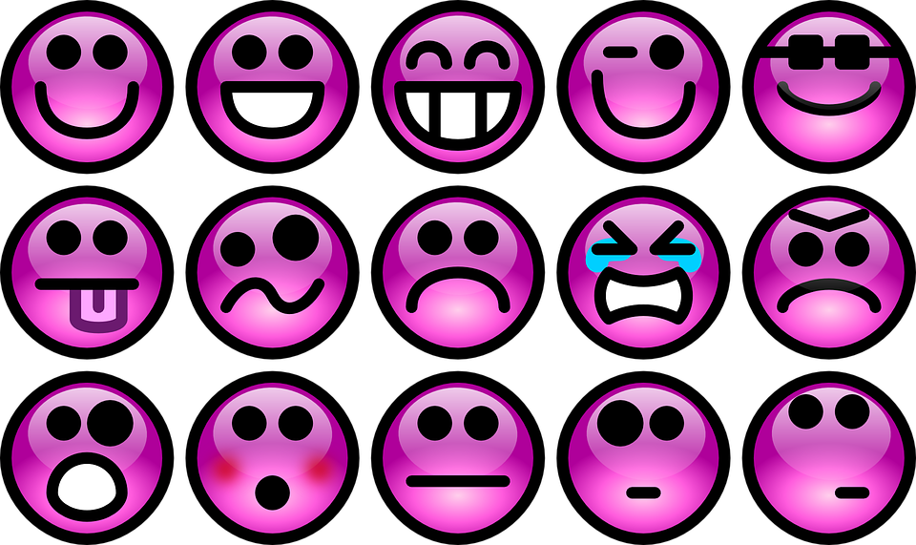
Point to the feeling or feelings that best describes how you are feeling today.

Tools for Taking Care of Yourself
Try taking deep breaths--big belly breaths--in and out!
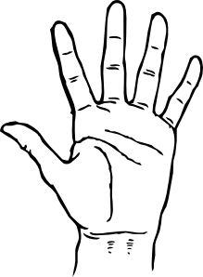
Now try the 5 Fingers breathing exercise!
*Start at your pinky finger
*As you move up the finger--breathe in
*As you move down the finger-breathe out
*Continue breathing in and out as you travel all the way to your thumb

Hopefully by the time you get to your thumb your body will feel more relaxed and calm (if not--do it again using your other hand).

Take Some Time to Appreciate

Draw or Write about person who you are thankful for

